AIF MDA Process Guide

Send Telemetry to Azure Event Hub

Process Name

Send Telemetry to Azure Event Hub.

A Java console application – mdaclient – has been built to facilitate one-way communication to an instance of an Azure Event Hub.

The client also updates the data store with a SendStatus indicator.

Boundaries

This process begins after telemetry is stored in Azure SQL and ends after the application completes sending a batch of messages to the Event Hub. Successful or failed attempts and mitigation procedures are out of scope & not covered in this document.

Preconditions: TelemetryData table with records for a single ReelIdentifier that have either an empty SendStatus field or a SendStatus field other than *Sent*.

Outputs

A batch of serializable JSON messages formatted as EventData that are to be received by an instance of Azure Event Hub.

During the course of its operation, the mdaclient should update the SendStatus field of the TelemetryData table in the aifmda database on Azure SQL to either *Sent* or *Failed*.

Inputs

A single ReelIdentifier is input to the mdaclient application.

Activities

1. Verify TelemetryData table has records that need to be sent (optional).

* Connect MMS to the aifmda database on Azure SQL: capaif.database.windows.net
* Execute SQL command:

SELECT COUNT(*) AS [NotSent]

FROM [aifmda].[dbo].[TelemetryData]

**WHERE ReelIdentifier='<REEL_IDENTIFIER>' and SendStatus is NULL**

1. Run mdaclient jar.

* Open a command console
* Navigate to the project’s top-level directory:

cd C:\Users\nocode\Documents\IAF_MDA.project_sourcecode\Machine%20Data%20Analysis\

* Execute this java command to run the jar file:

java -jar mdaclient/target/mdaclient-x.y.z-SNAPSHOT.jar

Diagrams

SQL to query for number of messages that will be sent to the Event Hub

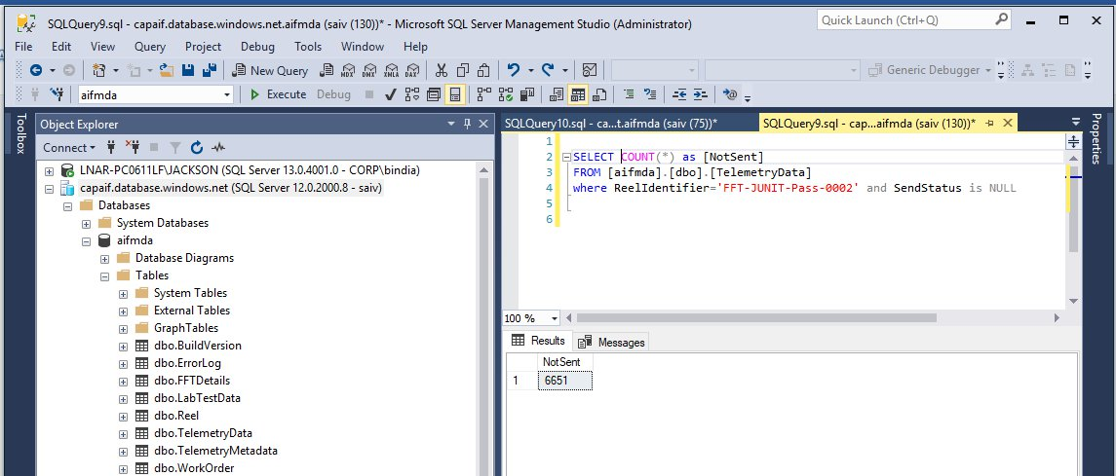

command console to execute mdaclient jar

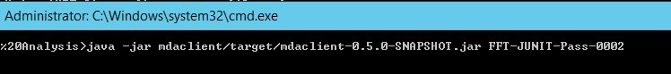

console output log for mdaclient (informational only)

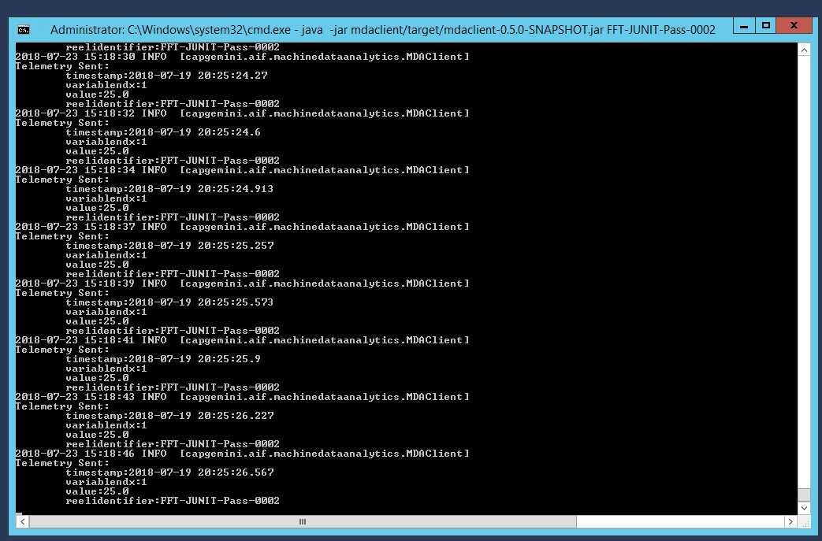

About Capgemini

A global leader in consulting, technology services and digital transformation, Capgemini is at the forefront of innovation to address the entire breadth of clients’ opportunities in the evolving world of cloud, digital and platforms. Building on its strong 50-year heritage and deep industry-specific expertise, Capgemini enables organizations to realize their business ambitions through an array of services from strategy to operations. Capgemini is driven by the conviction that the business value of technology comes from and through people. It is a multicultural company of 200,000 team members in over 40 countries. The Group reported 2016 global revenues of EUR 12.5 billion.

Learn more about us at [www.capgemini.com](http://www.capgemini.com)

This message is intended only for the person to whom it is addressed. If you are not the intended recipient, you are not authorized to read, print, retain, copy, disseminate, distribute, or use this message or any part thereof. If you receive this message in error, please notify the sender immediately and delete all copies of this message.

This message contains information that may be privileged or confidential and is the property of the Capgemini Group.  
Copyright © 2017 Capgemini. All rights reserved.